Delete ACL and Project Outcome
Project Development Phase | 7 of 7
Project | Script-Controlled ACL - Restrict Record Access Based on Field Value
Date / Team ID | 1 October 2026 | Team ID: [enter team ID]

Purpose
Complete the CRUD access model with a delete ACL, then record the project’s expected outcome and the evidence to capture during user acceptance testing.

Delete ACL configuration
Setting | Value
Type / Operation | Record / delete
Name | Institution Details [u_institution_details] / --None--
Decision type / Active | Allow If / selected
Admin overrides | Selected
Requires role | bb4
Advanced script | Target condition Branch=EEE; not present in the supplied Delete ACL screenshot.

Delete script
answer = current.getValue('u_branch') == 'EEE';

- Elevate to security_admin and create a record ACL for Operation delete on Institution Details.
- Set Allow If, Active, and Admin overrides. Add bb4 to Requires role. The supplied Delete screenshot is role-only; add and verify the Branch predicate before claiming field-based enforcement.
- The supplied Delete ACL screenshot shows bb4 but no Advanced script. Add and verify the Branch condition before claiming field-based delete enforcement; save and confirm the rule is active.
- Use disposable sample records only. Test deleting an EEE row as EEE User and a non-EEE row as a user without the project roles.
- Confirm an administrator can delete test records in every Branch when Admin overrides is enabled.

Expected project outcome
Target outcome (pending verification): The table uses EEE, ECE, and CSE Branch values. The intended ACL map is bb1 Read, bb2 Create, bb3 Write, and bb4 Delete, with field-sensitive access limited to Branch=EEE. Supplied captures do not prove this full model: the Read script checks bb1 only; Create checks bb2; Delete checks bb4 without an Advanced script; Write screenshots disagree between bb3 and u_institution_details_user; and the populated/empty list captures are not allow/deny tests. Update and test the rules before reporting field-based access as complete.

Acceptance test record
User / role | Operation | Branch | Expected | Actual / status
EEE User / bb1 | Read | EEE | Allow | To test
EEE User / bb1 | Read | ECE or CSE | Deny | To test
EEE User / bb2 | Create | EEE | Allow after create guard is verified | To test
EEE User / bb2 | Create | ECE or CSE | Deny by server-side validation | To test
EEE User / bb3 or u_institution_details_user (reconcile) | Write | EEE | Allow | To test
EEE User / bb3 or u_institution_details_user (reconcile) | Write | ECE or CSE | Deny | To test
EEE User / bb4 | Delete | EEE | Allow on disposable test record | To test
EEE User / bb4 | Delete | ECE or CSE | Deny | To test
Administrator | CRUD | Any branch | Allow with Admin overrides | To test
User without bb1-bb4 | Read / Write / Delete | Any branch | Deny | To test

Evidence to add Capture the ACL form and authorized/denied results from your own ServiceNow instance. The supplied list screenshots show populated and empty states, but neither proves ACL denial. The Actual / status cells remain To test.

Final review
- Confirm the field internal name and stored Choice value before relying on the script literal. Supplied screenshots do not yet prove successful allow/deny tests.
- Check the matching table ACLs, field ACLs, wildcard ACLs, and inherited ACLs if an expected result differs.
- Use the platform’s ACL debugging tools and rerun the acceptance matrix after every ACL change.

References
Project walkthrough: YouTube demonstration
ServiceNow documentation: Configure an ACL | ACL types | Explore ACLs

Screenshot evidence and implementation alignment
Evidence finding: The dedicated Delete form requires bb4 and does not show an Advanced script. The list screenshots show one populated list and one empty list; neither alone demonstrates that access was correctly allowed or denied. Record actual test results only after testing as each role.
Delete record ACL form requires role bb4. No Advanced field-value script is shown in this capture.
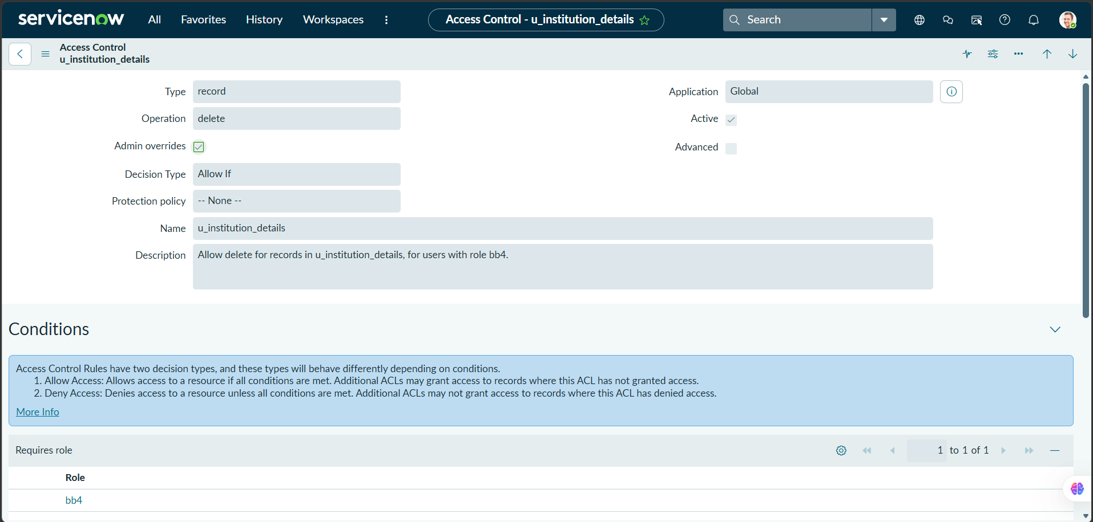

ACL conditions screenshot shows bb4 for the delete permission.
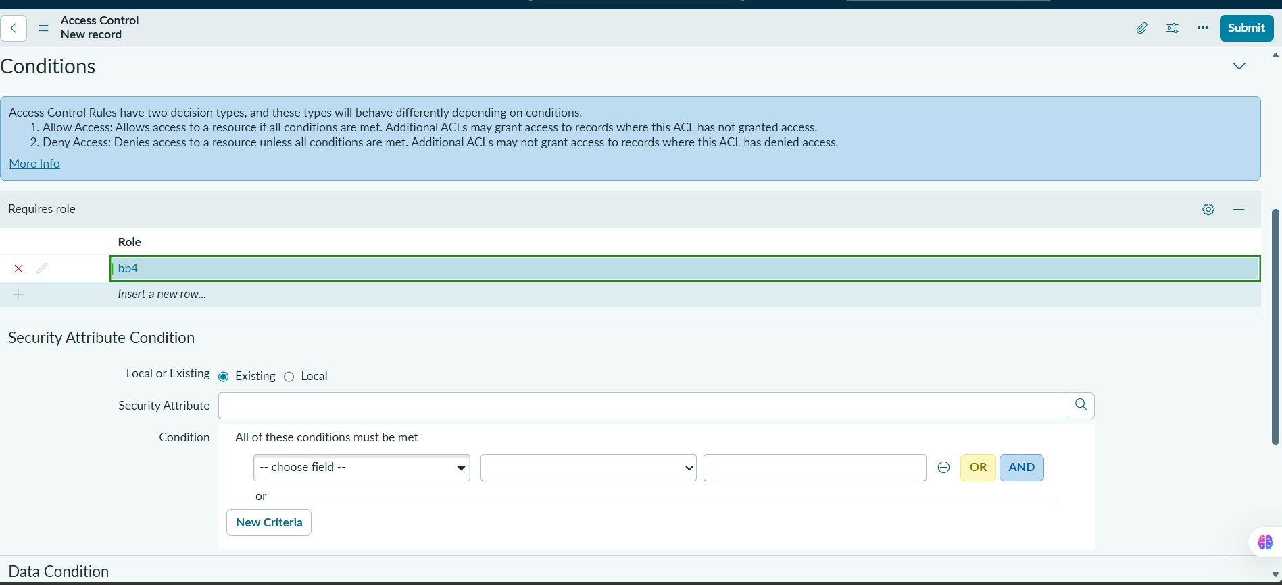

Institution Details list screenshot displays populated records across branches. A populated list alone does not prove that ACL filtering works.
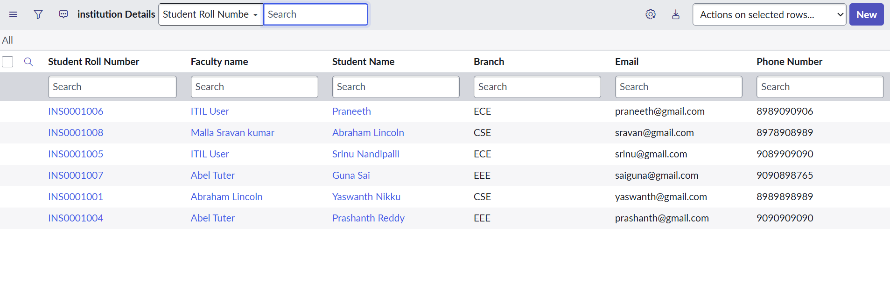

The captured list says “No records to display.” This records an empty list state but does not, by itself, prove that an ACL denied access.
